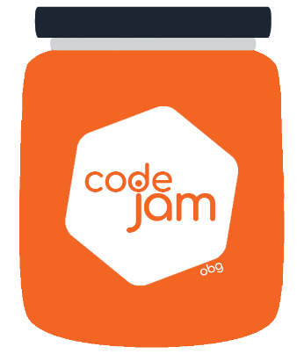

Challenge 1: Dog Head

Thursday 2nd of November an OBG PO came to the grooming session with a rather strange request for the next OBG mobile brand…. The brand team need a Dog head created in the front page. You know deep down that this is only the start of a bloody and long task….

What you need to do:

1. The time to complete is **30min**
2. Each team member has 10min to code.
3. The rest of the team can assist without coding (helping, giving ideas).
4. Create a dog head inside the assigned space leaving room for future use.
5. The dog should be created purely with HTML/CSS and without the use of any images (bitmap or vector) or canvas element.
6. You can use any properties from CSS and anything that help you to do that.